LAB NO 1 (IT LAB)

HRITIK BANSAL

180905105

CSE A 15

Q1) <!DOCTYPE html>

<html>

<head>

<title>Q1</title>

<script src="https://ajax.googleapis.com/ajax/libs/jquery/3.5.1/jquery.min.js"></script>

<script type = "text/javascript" language = "javascript">

$(document).ready(function(){

$(".btn").click(function(){

$("div").animate({left:"0px"})

})

})

</script>

<style type="text/css">

table {

font-family: arial, sans-serif;

border-collapse: collapse;

}

td, th {

border: 1px solid #dddddd;

text-align: left;

padding: 8px;

}

tr:nth-child(even) {

background-color: #dddddd;

}

.main-container{

display: flex;

flex-direction: column;

}

.sub-container{

position: relative;

left: 250px;

}

</style>

</head>

<body>

<div class="container">

<div class="sub-container">

<table>

<tr>

<th>FRUIT</th>

<th>COLOUR</th>

<TH>PRICE</TH>

</tr>

<tr>

<td>Apple</td>

<td>Red</td>

<td>190/kg </td>

</tr>

<tr>

<td>Grapes</td>

<td>Green</td>

<td>90/kg </td>

</tr>

</table>

<div class="image">

<img src="apple.jpg" alt="apple" width="300" height="300">

</div>

<div class="btn">

<button type="button">Click here</button>

</div>

</div>

</div>

</body>

</html>

OUTPUT:

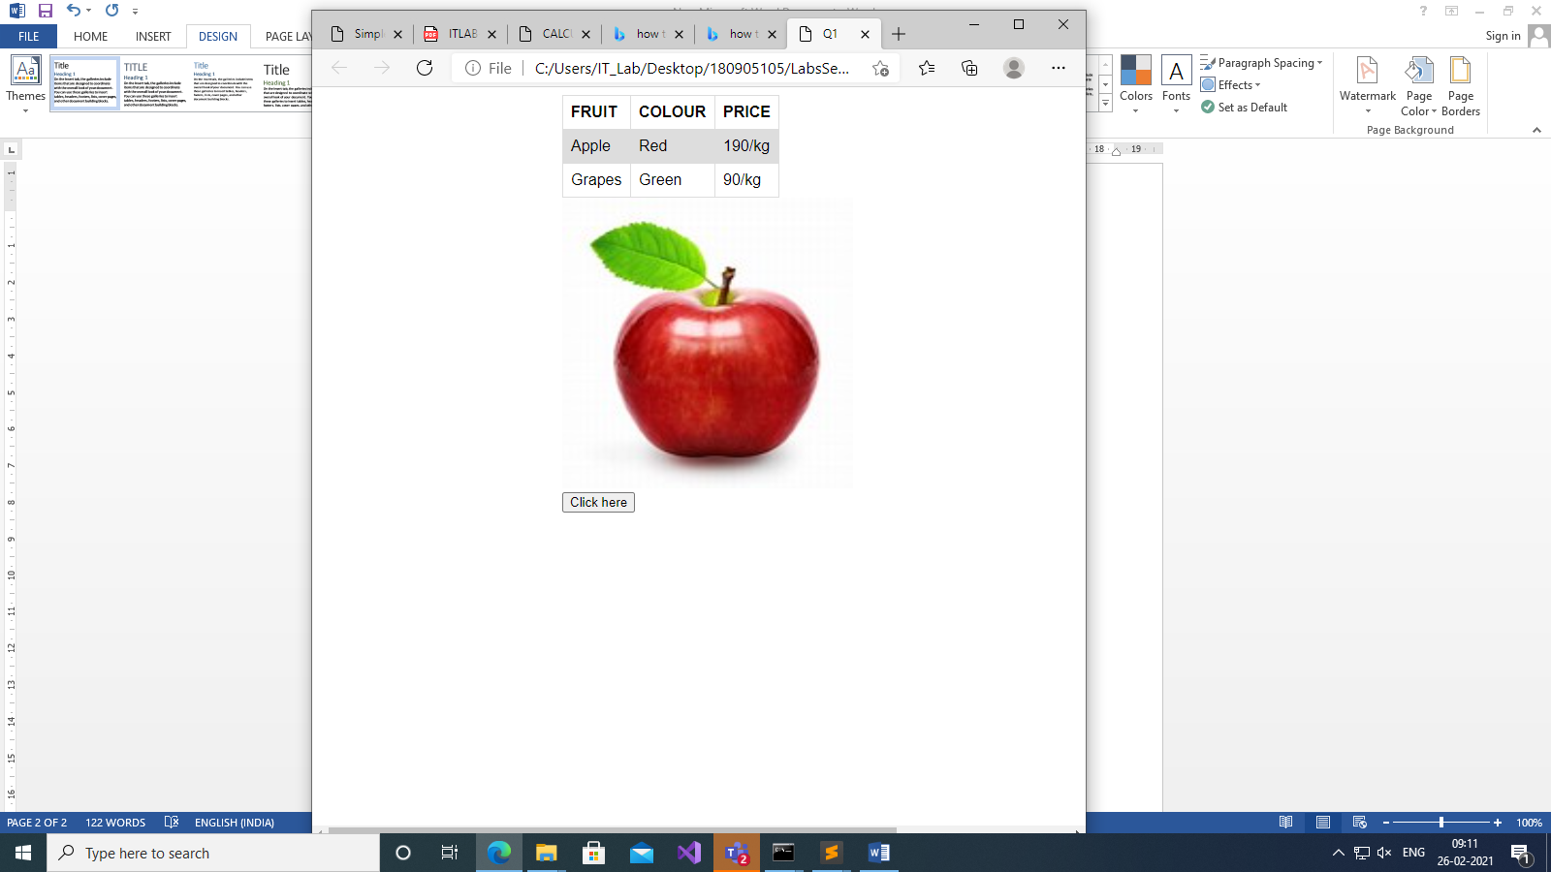 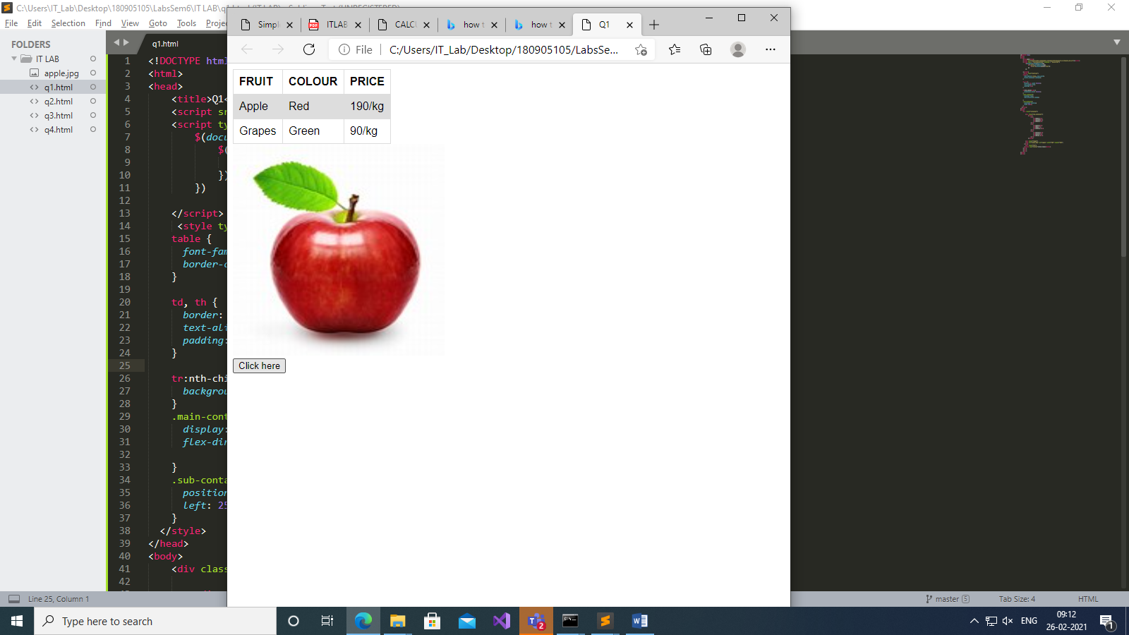

Q2)

<!DOCTYPE html>

<html>

<head>

<title>Q1</title>

<script src="https://ajax.googleapis.com/ajax/libs/jquery/3.5.1/jquery.min.js"></script>

<script type = "text/javascript" language = "javascript">

$(document).ready(function(){

$(".btn").click(function(){

$("div").animate({left:"0px"})

})

})

</script>

<style type="text/css">

table {

font-family: arial, sans-serif;

border-collapse: collapse;

}

td, th {

border: 1px solid #dddddd;

text-align: left;

padding: 8px;

}

tr:nth-child(even) {

background-color: #dddddd;

}

.main-container{

display: flex;

flex-direction: column;

}

.sub-container{

position: relative;

left: 250px;

}

</style>

</head>

<body>

<div class="container">

<div class="sub-container">

<table>

<tr>

<th>FRUIT</th>

<th>COLOUR</th>

<TH>PRICE</TH>

</tr>

<tr>

<td>Apple</td>

<td>Red</td>

<td>190/kg </td>

</tr>

<tr>

<td>Grapes</td>

<td>Green</td>

<td>90/kg </td>

</tr>

</table>

<div class="image">

<img src="apple.jpg" alt="apple" width="300" height="300">

</div>

<div class="btn">

<button type="button">Click here</button>

</div>

</div>

</div>

</body>

</html>

OUTPUT:

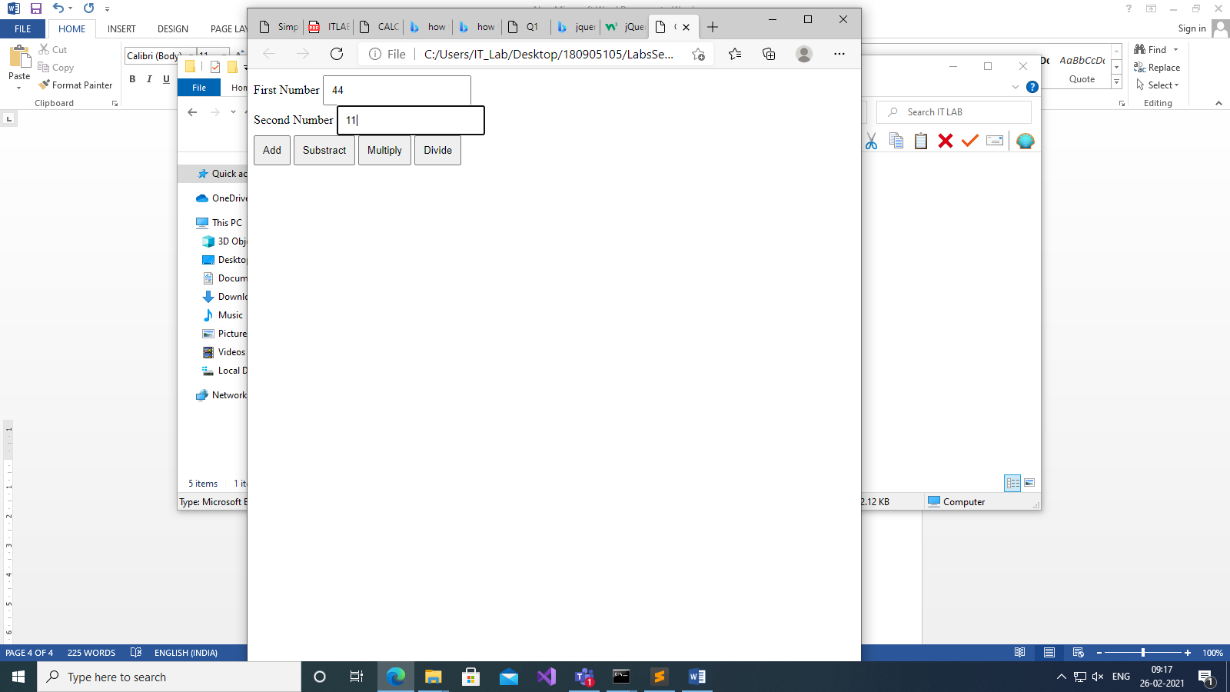 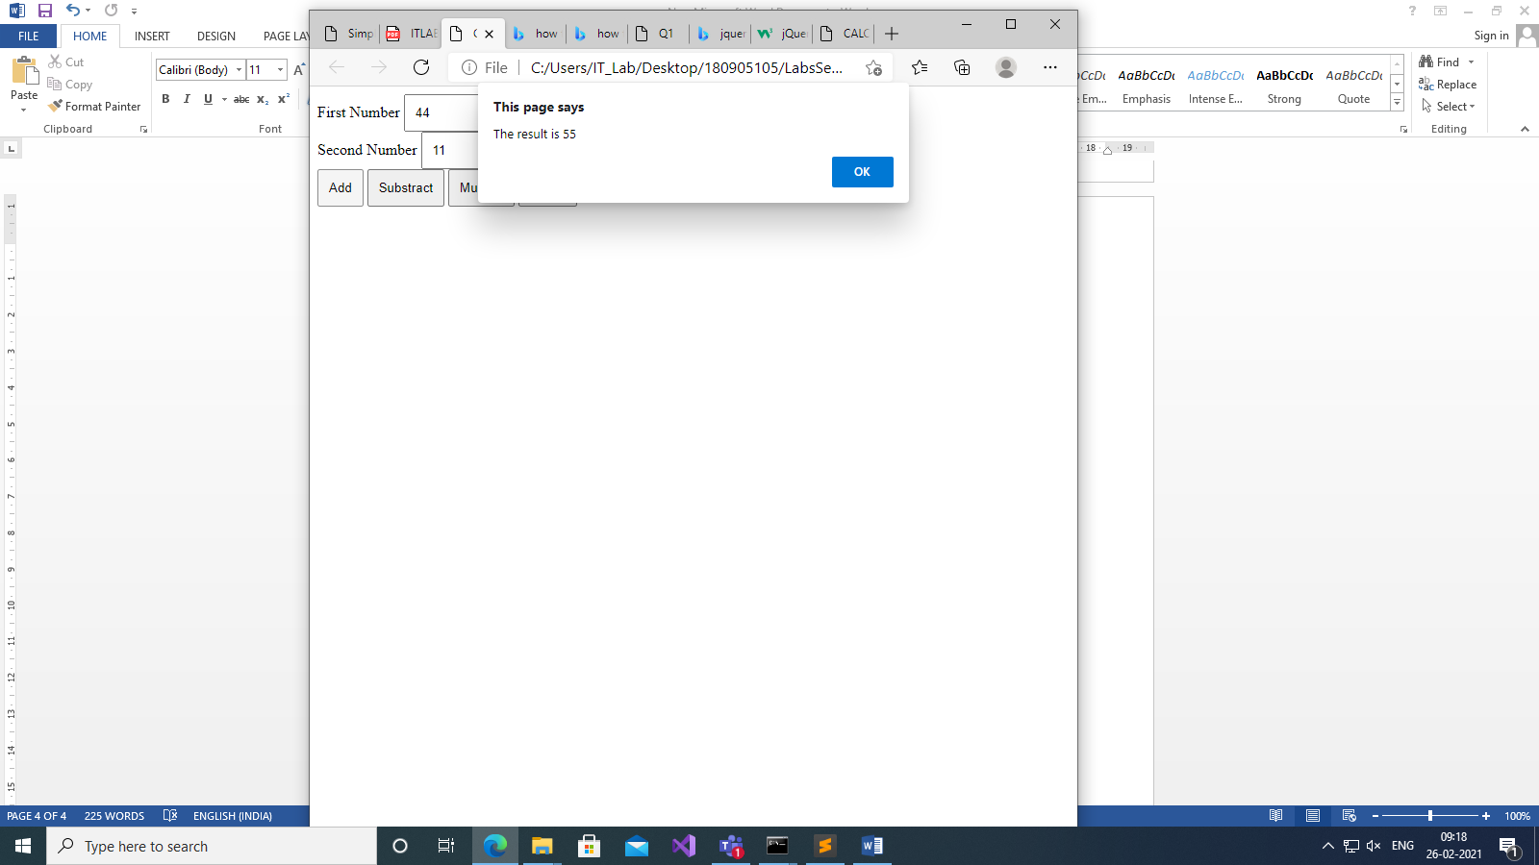

Q3)

<!DOCTYPE html>

<html>

<title>

Birthday Card

</title>

<script src="https://ajax.googleapis.com/ajax/libs/jquery/3.5.1/jquery.min.js"></script>

<script>

$(document).ready(function(){

$("button").click(function(){

$("#divright").css("background-color",$("#bgcolor").val());

$("#greet").css("font-family",$("#fonttype").val());

$("#greet").css("font-size",parseInt($("#text1").val()));

if($("#None").is(":checked")){

$("#divright").css("border-style","None");

}

else if($("#Double").is(":checked") && $("#Solid").is(":checked")){

$("#divright").css("border-style","Double Solid",);

}

else if($("#Double").is(":checked")){

$("#divright").css("border-style","Double");

}

else if($("#Solid").is(":checked")){

$("#divright").css("border-style","Solid");

}

$("#greet").text($("#txarea1").val());

if($("#checkbox1").prop("checked")==true){

$("img").attr("src", "bday.jpg");

$("img").attr("width", "300px");

$("img").attr("height", "300px");

}

});

});

</script>

<body>

<body>

<div id="divright" style="position: absolute; width: 400px; height: 700px;

right:100px; align-items: center">

<p id="greet" align="center"></p>

<img width=0px height=0px style="margin-left: 50px">

</div>

<div style="position: absolute; left: 100px">

<h1>Birthday Card</h1>

<p1>Choose a bg color</p1>

<select id="bgcolor">

<option value="Yellow">Yellow</option>

<option value="Blue">Blue</option>

</select>

<br></br>

<p1>Choose a font</p1>

<select id="fonttype">

<option value="Verdana">Verdana</option>

<option value="Times New Roman">Times New Roman</option>

</select>

<br></br>

<p1>Choose a font size</p1>

<input type="text" id="text1">

<p>Choose a border Style</p>

<input type="radio" id="None" value="None">

<label for="None">None</label><br>

<input type="radio" id="Double" value="Double">

<label for="Double">Double</label><br>

<input type="radio" id="Solid" value="Solid">

<label for="Solid">Solid</label>

<br>

<br>

<p1>Add default Picture</p1>

<input type="checkbox" id="checkbox1" value="cb1">

<br>

<br>

<p1>Enter greeting text below</p1><br><br>

<input type="textarea" id="txarea1"><br><br>

<button>Update</button>

</div>

</body>

</html>

OUTPUT:

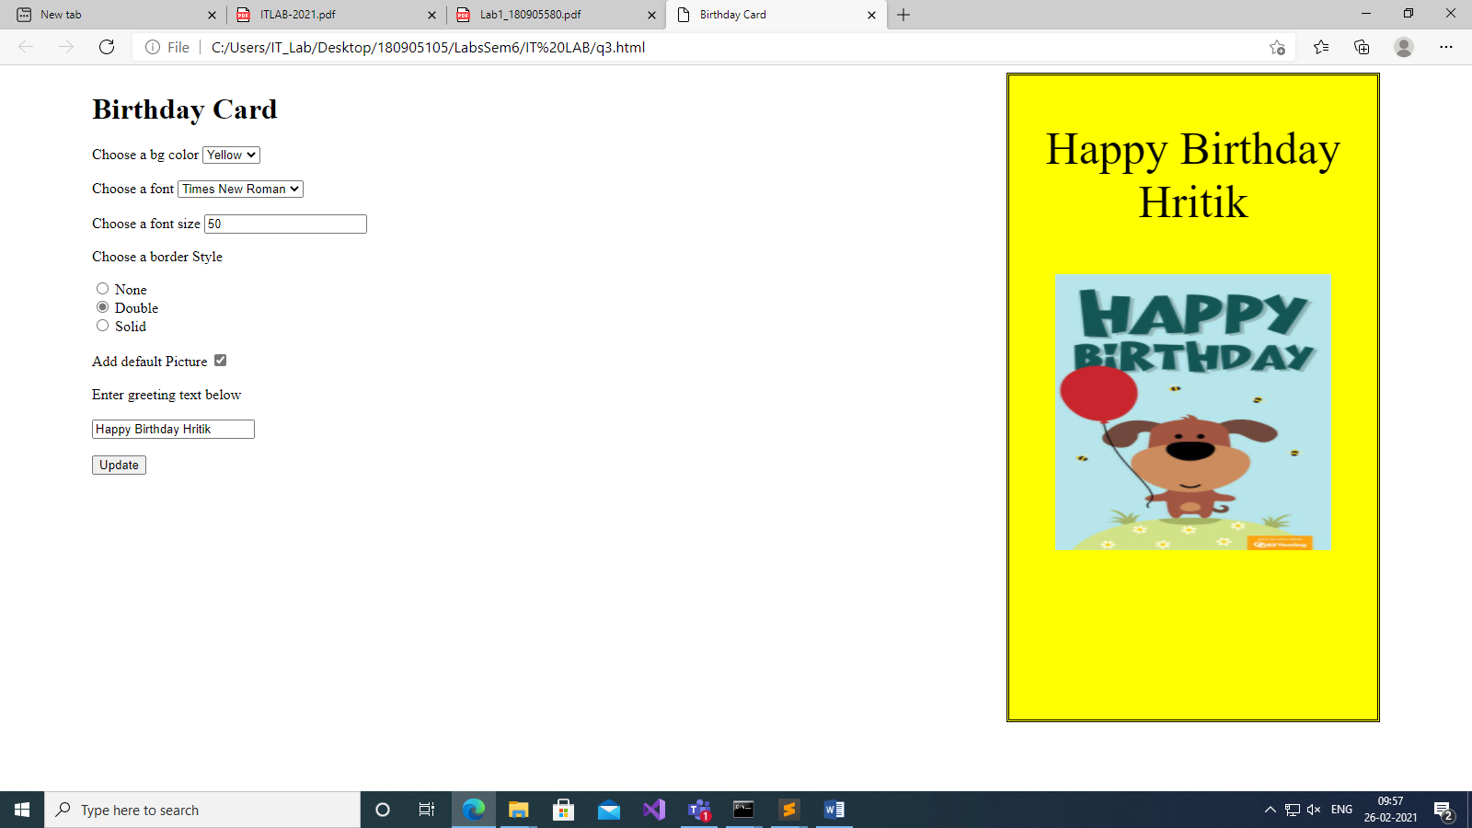

Q4)

<!DOCTYPE html>

<head>

<title>Exercise 4</title>

<style>

.dropmenu1{

margin-bottom:30px;

display: block;

padding: 5px 10px;

font-size: 1.4rem;

outline: none;

}

#bigbox{

width: 60%;

}

</style>

<script src="https://ajax.googleapis.com/ajax/libs/jquery/3.5.1/jquery.min.js"></script>

<script>

$(document).ready(()=>{

let mVal = 0;

let lVal = 0;

$("#checkBox").hide();

$("#quantLap").hide();

$("#quantMob").hide();

$(".dropmenu1").change(() => {

$("#checkBox").show();

});

$("#mobOp").change(()=>{

if(mVal === 0){

$("#quantMob").show();

mVal++;

}

else{

$("#quantMob").hide();

mVal = 0;

}

});

$("#lapOp").change(()=>{

if(lVal === 0){

$("#quantLap").show();

lVal++;

}

else{

$("#quantLap").hide();

lVal = 0;

}

});

let vals = {

"hp":{

"mobile": 6000,

"laptop": 67700

},

"nokia":{

"mobile": 7890,

"laptop": 58900

},

"samsung":{

"mobile": 9009,

"laptop": 74500

},

"motorola":{

"mobile": 7345,

"laptop": 88550

},

"apple":{

"mobile": 9870,

"laptop": 99000

},

}

$('#btn1').click(()=>{

let company = $(".dropmenu1 option:selected").val();

let mobVal = $("input[name='mobBox']:checked").val();

let lapVal = $("input[name='lapBox']:checked").val();

let mobQu = parseInt($("#mobQuant").val());

let lapQu = parseInt($("#lapQuant").val());

if(mobVal && lapVal){

let finalExpense = mobQu\*(vals[company].mobile) +

lapQu\*(vals[company].laptop);

alert("Price of 1 mobile: " + vals[company].mobile + "\nPrice of 1 laptop: "+ vals[company].laptop+"\nFinal price of all "+company+" products: "+

finalExpense);

}

else if(mobVal){

let finalExpense = mobQu\*(vals[company].mobile);

alert("Price of 1 mobile: " + vals[company].mobile + "\nFinal price of all"+company+" products: "+ finalExpense);

}

else if(lapVal){

let finalExpense = lapQu\*(vals[company].laptop);

alert("Price of 1 laptop: " + vals[company].laptop + "\nFinal price of all"+company+" products: "+ finalExpense);

}

else{

alert("Enter all necessary fields");

}

});

})

</script>

</head>

<body>

<div id="bigbox">

<div id="firstbox">

<p class="para">Choose a vendor:</p>

<select class="dropmenu1">

<option value="hp">HP</option>

<option value="nokia">Nokia</option>

<option value="samsung">Samsung</option>

<option value="motorola">Motorola</option>

<option value="apple">Apple</option>

</select>

<div id="checkBox">

<input type = "checkbox" id = "mobOp" value = "mobile"

name="mobBox" /> Mobile <br>

<input type = "checkbox" id = "lapOp" value = "laptop" name="lapBox" />

Laptop <br>

</div>

<div id="quantMob">

<p class="para">Enter quantity of mobiles:</p>

<input type="input" id="mobQuant" placeholder="Enter quantity ...">

</div>

<div id="quantLap">

<p class="para">Enter quantity of laptops:</p>

<input type="input" id="lapQuant" placeholder="Enter quantity ...">

</div>

<button id="btn1">Produce bill</button>

</div>

</div>

</body>

</html>

OUTPUT:

